SECTION A: Multiple-choice questions

Use the following information for Questions 1 and 2
A fuel cell which uses methanol as the energy source has been developed by chemists. The simplified
diagram below shows its structure.

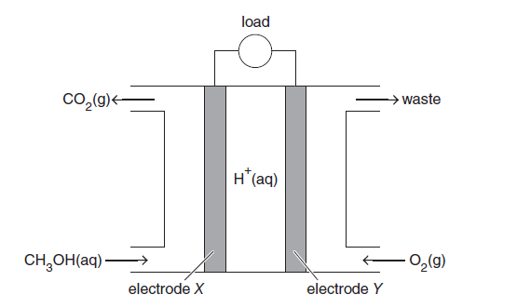

Question 1
The fuel cell is different to a secondary cell because in a fuel cell
A. | a spontaneous redox reaction is used.
B. | reactants are continuously replenished.
C. | the polarity of the electrodes is reversed.
D. | cations travel towards the cathode.
Answer is B
A and D are both features of cells which generate electrical energy. The polarity of electrodes in fuel cellsand secondary cells is the same. C is incorrect. In secondary cells, the reaction products remain in contactwith the electrodes so that the cell reaction can be reversed by the input of electrical energy. In fuel cells, the reactants are constantly being fed to the electrodes.

Question 2
Methanol can be produced from a number of sources.
Which one of the following sources is least sustainable?
A. | methane extracted from natural gas being converted to methanol in a two-step process
B. | decomposition of organic waste producing methane from which methanol is generated
C. | fermentation of carbohydrates producing a mixture of alkanols, including methanol
D. | modified bacteria using plant structural material in special digesters to produce methanol

Answer is A
Natural gas is a fossil fuel and thus the supply is finite. Extracting methane and then converting it to
methanol is not sustainable. A is the required answer. B, C and D involve using microbes on raw materials
which are of plant origin and which can be regrown. These are all sustainable methods.

Question 4
A galvanic cell is constructed from a chlorine half-cell connected to a manganese half-cell under standard laboratory conditions.
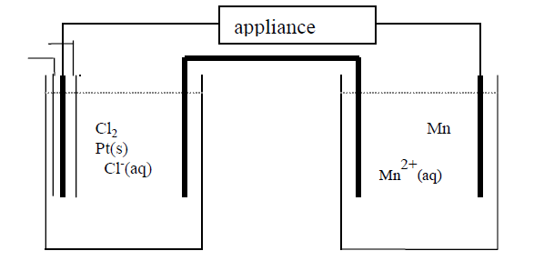
Cl⁻ (aq)
Mn²⁺ (aq)
Cl₂ (g)

Pt(s)
Mn(s)

In this cell
 | oxidant | Reductant | Negative Electrode | Positive Electrode
A. | Mn²⁺ | Cl— | Pt | Mn
B. | Mn | Cl₂ | Mn | Pt
C. | Cl₂ | Mn | Mn | Pt
D. | Cl— | Mn²⁺ | Mn | Pt

Answer is C:
In this cell, Cl₂ (strongest oxidant) will react with Mn (strongest reductant). Cl₂ will reduce to Cl⁻ at the cathode (+). Mn(s) undergoes oxidation reaction at the anode (-)

Question 5
A 100 g sample of a metal was heated to 100ºC and then quickly immersed in 200 g of water in an insulated container. The water was initially at 22.6ºC and when the water and the metal reached thermal equilibrium, the temperature had increased to 29.0ºC.

What was the specific heat capacity, in J g⁻¹ ºC⁻¹, of the metal?

A. | 0.376
B. | 0.754
C. | 3.26
D. | 4.18
Answer is B
Assume that all the energy absorbed by the water is the energy ‘lost’ from the
heated metal sample.
Energy into water = 4.18 J g⁻¹ ºC⁻¹ $×$ 200 g $×$ (29.0-22.6) = 5.35x10³ J
Energy lost from metal = SHC $×$100 g $×$ (100 – 29.0) ºC
5.35x10⁻³ = SHC $×$ 7100
SHC = $\frac{5.35×{10}^{3} }{7100}$ = 0.754 J g⁻¹ ºC⁻¹

Question 6
A food company is investigating using methane produced by bacterial decomposition of food waste to reduce the use of heating oil which has an average energy value of 38.5 MJ L⁻¹. What is the maximum volume of heating oil that would be saved if 2.45 $×$ 10⁵ L of methane, stored at SLC, is produced from food waste?

A. | 231 L.
B. | 431 L.
C. | 636 L.
D. | 2.56 $×$ 10³ L.
Answer is A
n(CH₄) produced = 2.45x10⁵ L / 24.5 L mol⁻¹ = 1.00x10⁴ mol

Table 13 Data Book: ΔH_{combustion} (CH₄) = -889 kJ mol⁻¹
Energy available from methane = 1.00 $×$ 10⁴ mol $×$ 889 kJ mol⁻¹ = 8.89 $×$ 10⁶ kJ = 8.89 $×$ 10³ MJ

Volume of heating oil saved = Energy from methane/ Energy per L oil
= 8.89 $×$ 10³ MJ / 38.5 MJ L⁻¹
= 231 L

Question 9
Consider the following thermochemical equations:

Pb_{(s)} + CO_{(g)} PbO_{(s)} + C_{(s)} ΔH = -106.8 kJ mol⁻¹
2C_{(s)} + O_{2(g)} 2CO_{(g)} ΔH = -221.0 kJ mol⁻¹

The change in heat energy when 250 g of lead reacts with oxygen to form lead oxide is closest to:

A. | -262 kJ
B. | +262 kJ
C. | -435 kJ
D. | +435 kJ  Answer is B: Lead reacts with oxygen to form lead oxide according to the following equation: 2Pb_{(s)} + O_{2(g)} 2PbO_{(s)}  To obtain this equation from the reactions given, multiply reaction (1) by two, cancel  common reactants and products and then add the equations together.  Reaction (1) 2Pb_{(s)} +2 CO_{(g)} 2PbO_{(s)} + 2C_{(s)} ΔH = -106.8 x 2 kJ mol⁻¹  Reaction (2) 2C_{(s)} + O_{2(g)} 2CO_{(g)} ΔH = -221.0 kJ mol⁻¹  Hence, repeat this same mathematical manipulation for the ΔH (e.g. double ΔH1, and then add ΔH1 and ΔH2)  ΔH _{total} = (2 x -106.8) + -221.0 = - 434.6 kJ/mol  Next determine the heat released when 250 g of lead is reacted:  n(Pb) = $\frac{250g}{207.2}=1.207 mol$  2 mol Pb releases 434.6 kJ  1.207 mol Pb releases x kJ  $$\frac{x}{434.6}=\frac{1.207}{2}$$  $$x=262.2 kJ$$  The answer will be positive since the question asks for HEAT RELEASED, not for the enthalpy.
Question 10
The E⁰ values for reduction reactions involving chromium are shown below.

Reduction reactions | E⁰ values
Cr₂O₇^{2—}_{(aq)} + 14H⁺_{(aq)} + 6e⁻ 2Cr³⁺_{(aq)} + 7 H₂O_{(l)} | 1.33 V
Cr³⁺_{(aq)} + e— Cr²⁺_{(aq)} | -0.41 V
Cr³⁺_{(aq)} + 3e— Cr_{(s)} | -0.76 V
Cr²⁺_{(aq)} + 2e— Cr_{(s)} | -0.91 V

Which of the following could be used to reduce chromium from an oxidation state of +6 to +3 only?

A. | Cu
B. | Al
C. | Mn
D. | Fe  Answer is A:  Cr₂O₇^{2—} will spontaneously reduce to Cr³⁺ when it reacts with anything lower than it on the  right hand side of the electrochemical series (Cu_{(s)}, Cr²⁺_{(aq)}, Fe_{(s)}, Cr_{(s)}, Mn_{(s)} and Al_{(s)}). However, only Cu_{(s)} will reduce it to 2Cr³⁺_{(aq)} without any further reduction. This is because all of the other substances lie below Cr³⁺_{(aq)} on the electrochemical series and will therefore cause the further reduction of Cr³⁺_{(aq)} or even Cr_{(s)}

Use the following information to answer Questions 11 and 12.

The chemical reaction represented below proceeds readily and rapidly in aqueous solution at room temperature.

Br_{2(aq)} + SO_{2(aq)} + 2H₂O_{(l)} 2Br–_{(aq)} + 4H⁺_{(aq)} + SO₄^{2–}_{(aq)}

It is proposed that a galvanic cell be constructed using this reaction, as shown below.
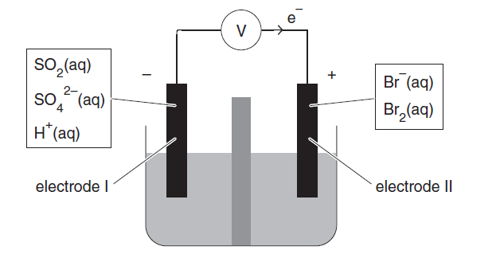
membranes

${Br}^{- }$(aq)
${Br}_{2}$ (aq)
$${SO}_{2}(aq)$$
${ SO}_{4}^{2-}$ (aq)
H⁺ (aq)

Question 11
When this cell is operating, electrode I will be the

A. | anode, at which SO₂ undergoes oxidation.
B. | anode, at which Br₂ undergoes oxidation.
C. | cathode, at which SO₂ undergoes reduction.
D. | cathode, at which Br₂ undergoes reduction.

Answer is A
Electrons are moving from electrode I to II via the external circuit. Hence electrode I is the anode, where oxidation occurs.
SO₂ is the reductant, undergoing oxidation at the negatively charged anode (electrode I) to produce
SO₄^{2–}. The oxidation number of Sulfur increases from + 4 to +6.

Br₂ is the oxidant, undergoing reduction at the positively charged cathode (electrode II) to produce Br–.

Question 12
When the cell is operating, the pH of the solution close to electrode I would initially be expected to:

A. | increase.
B. | decrease.
C. | remain unchanged.
D. | fluctuate rapidly.
Answer is B
The reaction occurring at electrode I is SO₂ + 2H₂O → SO₄ ^{2–} + 4H⁺ + 2e–. As reaction proceeds, 4H⁺ is produced, and so the pH will decrease.

END OF SECTION A

SECTION B

Instructions for Section B
Answer all questions in the spaces provided. Write using black or blue pen.
To obtain full marks for your responses you should
- give simplified answers with an appropriate number of significant figures to all numerical questions; unsimplified answers will not be given full marks.
- show all working in your answers to numerical questions. No marks will be given for an incorrect answer unless it is accompanied by details of the working.
- Make sure chemical equations are balanced and that the formulas for individual substances include an indication of state; for example, H_{2(g);} NaCl_{(s)}

Question 1 (5 marks)
In a problem-solving exercise, a student was provided with four half-cells under standard laboratory conditions. The aim was to place the half-reactions in the correct order in an electrochemical series. The half-cell reduction reactions, in random order, are shown in the table below.

Half-cells | Reduction half-equations
A | Cr²⁺_{(aq)} + 2e Cr_{(s)}
B | NO₃—_{(aq)} + 4H⁺_{(aq)} + 3e NO_{(g)} + 2H₂O_{(l)}
C | Au³⁺_{(aq)} + 3e Au_{(s)}
D | MnO₄—_{(aq)} + 3e MnO₄^{2—}_{(aq)}

In a series of experiments, two half-cells were connected at a time and experimental observations were made
as follows:
Half-cells | Reduction half-equations
A and B | Gas bubbles are produced at one electrode.
C and D | The gold electrode increases in mass.
B and C | The pH near one electrode decreases.

- i. Give the formula of an oxidant from the experiment which is known to be stronger
than acidified NO₃—_{(aq)}
Au³⁺_{(aq)} [1 mark]

ii. Give the formula of a reductant from the experiment which is known to be a stronger
reductant than NO(g).
Cr _{(s)} [1 mark]
1 + 1 = 2 marks

- Write the balanced equation for the cell reaction produced by connecting half cells A and B.
2NO₃⁻_{(aq)} + 8H⁺_{(aq)} + 3Cr_{(s)} −−> 2NO_{(g)} + 4H₂O_{(l)} + 3Cr²⁺_{(aq)} [1 mark]
1 mark

c. The standard hydrogen half-cell was not used in the problem-solving exercise.
Explain how the standard hydrogen half-cell could have been used in this exercise to gain further information about the correct order of the half-reactions in the electrochemical series given in the data booklet.

Connect each half-cell in turn to the standard hydrogen half-cell, noting the voltage and
polarity of each. [1 mark]

Those half-cells which are positive in the cell are given positive voltages and those which are negative are given negative voltages. Half-cell reactions can then be placed in order of decreasing voltage to generate an electrochemical series. [1 mark]

2 marks

Question 2 (8 marks)
Continued increases in the price of oil has sharpened focus on alternative fuels for motor vehicles, particular biochemical fuels and hydrogen. Hydrogen can be produced from water and used in hydrogen internal combustion engines or fuel cells.
A hydrogen energy cycle for the use of hydrogen as a fuel is represented below.

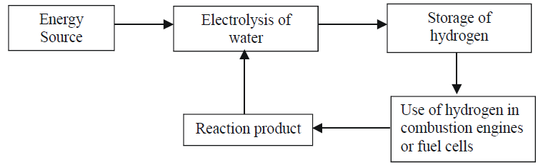

- Identify one concern currently associated with the production of biochemical fuels.
The use of crops that would normally be used in food production. This may be driving up food prices. [1 mark]

1 mark
b. i. What is the main environmental impact of the use of brown coal to generate electricity?
Production of CO₂ – contribution to global warming [ 1 mark] or
SO₂ can also be released into the environment but in much smaller quantities that CO_{2.}

ii. Identify two sources of electricity which may be used for the electrolysis of water but do not have the environmental impact of brown coal.
photovoltaic cells which convert solar energy into electrical energy, or generators driven by hydroelectricity, wind power, geothermal energy, nuclear energy or tidal power. [1 mark] for any two.

1 + 1 = 2 marks

c. i. Write a thermochemical balanced equation for the complete combustion of hydrogen gas.
2H_{2(g)} + O_{2(g)} → 2H₂O_{(g or l)} ΔH = -572 kJ mol⁻¹
[1 mark ] for balanced equation and states; [1 mark for correct value, sign and units of Δ]

ii. Determine the heat of combustion of hydrogen gas in kJ g^{–1.}
2 mole of hydrogen gas releases 572 kJ
This means that 4 g of H₂ releases 572 kJ
1 g of H₂ releases 572/4 = 143 kJ
Heat of combustion = 143 kJ/g. [1 mark]

2 + 1 = 3 marks

d. Hydrogen can be produced by the electrolysis of a dilute aqueous solution of potassium chloride. Write balanced half-equations for the reactions occurring at the (-) and (+) electrodes during this electrolysis.

(-) electrode:
Reaction is between the strongest oxidant and the strongest reductant, so the half-equations are
(-) electrode 2H₂O_{(l)} + 2e⁻ → H_{2(g)} + 2OH⁻_{(aq)} [1 mark ]
________________________________________________________________________

(+) electrode:
(+) electrode 2H₂O_{(l)} → O_{2(g)} + 4H⁺_{(aq)} + 4e⁻ [1 mark ]
________________________________________________________________________
2 marks

Question 3 (10 marks)
The molybdenum-air battery is typically lighter and provides more energy than an ordinary primary
battery because of the use of air, which is passed over the positive electrode. The battery is able to operate efficiently in either an acidic or alkaline electrolyte. The following half equations show the reduction of the molybdite ion (${MoO}_{4}^{2-}$) in different solutions.

H₂MoO_{4(aq)} + 6H⁺_{(aq)} + 6e⁻ Mo_{(s)} + 4H₂O_{(l)} E⁰ = -0.11 V

MoO₄ ²⁻_{(aq)} + 4H₂O_{(l)} + 6e⁻ Mo_{(s)} + 8OH⁻_{(aq)} E⁰ = -0.91 V

- i. Write the half-equation for the reaction at the cathode in an operating alkaline molybdenum-air battery.
The oxidant in air is O₂, which is reduced at the cathode Data Book Table 2
O_{2(g)} + 2H₂O_{(l)} + 4e- 4OH⁻_{(aq).} [1 mark]

- Write the overall equation for an operating alkaline molybdenum-air battery
Mo is oxidised at the anode, O₂ is reduced at the cathode.
Oxidation: Mo_{(s)} + 8OH⁻_{(aq)} MoO₄ ²⁻_{(aq)} + 4H₂O_{(l)} + 6e
Reduction: O_{2(g)} + 2H₂O_{(l)} + 4e- 4OH⁻_{(aq).}

Overall equation: multiply oxidation half-equation by 2 and reduction half-equation by 3, then add. Cancelling down species that appear on both sides.
2Mo_{(s)} + 4OH⁻_{(aq)} + 3O_{2(g)} 2MoO₄ ²⁻_{(aq)} + 2H₂O(l) [1 mark]

- What would be the expected operating voltage, at standard conditions, of an alkaline molybdenum-air cell?
O_{2(g)} + 2H₂O_{(l)} + 4e- 4OH⁻_{(aq).} E⁰= +0.40 V
Mo_{(s)} + 8OH⁻_{(aq)} MoO₄ ²⁻_{(aq)} + 4H₂O_{(l)} + 6e E0 = -0.91 V

Cell voltage alkaline version = 0.40 – (-0.91) = 1.31 V [1 mark]

1 + 1 + 1 = 3 marks
- Why can batteries such as the molybdenum-air battery contain a much greater proportion, by mass, of reductant than conventional primary cells?
Since the oxidant is supplied as needed from air it does not need to be stored in the battery. [1 mark]
1 mark

c. In a zinc-air cell, the anode reaction is represented by the half-equation

Zn_{(s)} + 2OH⁻_{(aq)} Zn(OH)_{2(s)} + 2e-

The maximum operating cell voltage under standard laboratory conditions is 1.65 V.

- Calculate the maximum amount of electrical energy, in kJ, available from the consumption of
1.00 mol Zn in an alkaline Zn-air battery.
Electrical energy = VIt = V x n(e) x Q
Oxidation of 1 mol Zn releases 2 mol e-
E from 1 mol Zn = 1.65 x 2 x 96500 = 3.18x10⁵J = 318 kJ [1 mark]

- Calculate the maximum amount of electrical energy, in kJ, available from the consumption of
1.00 mol of molybdenum in an alkaline molybdenum-air battery.
Oxidation of 1 mol Mo releases 6 mol e-
E from 1 mol Mo = 1.31 x 6 x 96500 = 7.58x10⁵ J = 758 kJ [1 mark]

- Energy density is the energy available per gram of reductant. Use workings to show that the energy density of an alkaline Zn-air cell is less than the energy density of an alkaline molybdenum-air cell, even though the molybdenum-air cell has a lower molar mass and higher cell voltage.
M(Zn) = 65.4 g mol L⁻¹
Energy per gram of Zn = 318 kJ mol-1 / 65.4 g mol-1 = 4.86 kJ g-1 [1 mark]

M(Mo) = 95.9 g mol L⁻¹
Energy per gram of Mo = 758 /95.9 = 7.90 kJ g-1 [1 mark]

1 + 1 + 2 = 4 marks

d. Lithium ion cells are secondary cells which are rechargeable. They have operating voltages up to 3.7 V. What are the two key requirements for correct recharging of a lithium ion cell?
The (-) negative terminal of the power supply (recharger) must be attached to the (-) electrode of the cell, and the (+) positive terminal of the recharger to the (+) electrode
of the cell. [1 mark]
The recharger must supply a voltage greater than 3.7 V per cell.[1 mark]

2 marks

Question 5 (5 marks)

Hydrocarbons are a common fuel which vary in energy densities. This means the same mass of two different fuels could produce different amounts of energy.

- What mass of pure methanol would release the same amount of energy as 1.00 g of methane?
CH₄(g) + 2O₂(g) → CO₂(g) + 2H₂O(g) ∆H = −889kJ/mol (from data booklet)

n(CH₄) = $\frac{m}{M}$ = $\frac{1.00}{16}$ = 0.0625 mol [1 mark]

1 mole CH₄ releases 889kJ of energy
0.0625mol releases x kJ of energy
By proportions,
x = 0.0625 x 889 = 55.56 kJ of energy [1 mark]

CH₃OH(l) + 2O2(g) → CO₂(g) + 2H₂O(g) ∆H = −725 kJ/mol (from data booklet)

1 mol CH₃OH releases 725 kJ of energy
X mol CH₃OH releases 55.6 kJ of energy
By proportions, x = $\frac{55.56}{725}$ = 0.0766 mol methanol

m(CH₃OH) = n x M
= 0.0766 x 32
= 2.4512
= 2.45 g [1 mark]

3 marks

b. i. What is the trend in the heats of combustion as the molecular mass of the hydrocarbons increase?
The heats of combustion increase with molecular mass of the hydrocarbons. As the hydrocarbons become larger, the number of C-H bonds increases. [1 mark] If the molecules contain more bonds, then there is more potential chemical energy being stored and which can be released upon combustion.

ii. How do the heats of combustion of hydrocarbons compare to those of the corresponding alcohol?
The corresponding alcohol has a lower heat of combustion. [1 mark]

1 + 1 = 2 marks

SECTION A: Multiple-choice questions

Question 3

Which of the following statements is true for an exothermic reaction:

- the energy absorbed to break the bonds in the reactants is greater than the energy released during the formation of the bonds in the product
- the activation energy of the forward reaction is smaller than the activation energy of the reverse reaction
- the change in enthalpy is positive
- increasing the temperature will drive the reaction forwards

B

Question 12
The thermochemical equation for the complete combustion of methane, CH₄, is:
CH₄ (g) + 2O₂ (g) CO₂ (g) + 2H₂O (g) ΔH = -889 kJ/mol
Which of the following energy profile diagrams best represents the energy changes that take place during this reaction?

A.
-889 kJ/mol
C.
-889 kJ/mol
B.
-889 kJ/mol
D.
-889 kJ/mol

A

Question 1 (5 marks)
On the graph below draw a reaction energy profile diagram using the following data for the equilibrium system:
reactants ⇌ products ΔH = −220 kJ mol⁻¹

The chemical potential energy for the products is 140 kJ mol⁻¹, and the activation energy for the uncatalysed forward reaction is 180 kJ mol⁻¹.
Be sure to label:
- The axes
- The scale used on the vertical axis
- The reactants and products
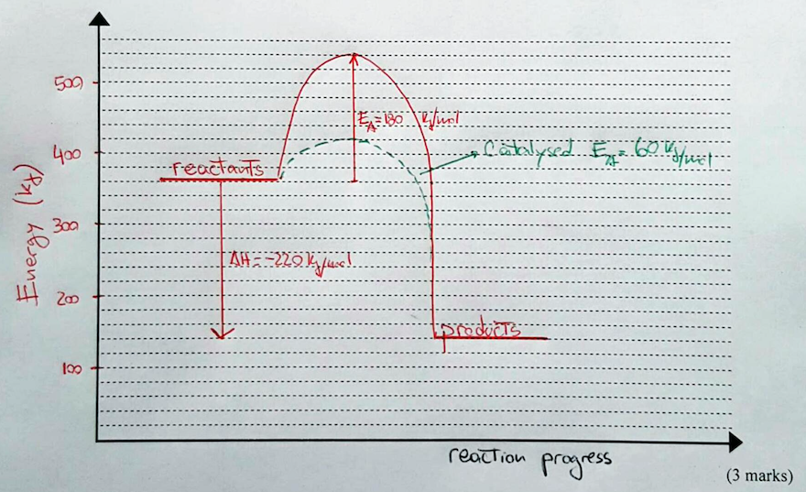

On the same diagram show the profile for the catalysed reaction where the activation energy for the forward reaction is 60 kJ mol⁻¹. Be sure to label this as the catalysed reaction.

(1 mark)
- Calculate the activation energy for the catalysed reverse reaction.
E_{A}= 220 kJ/mol + 60 kJ/mol = 280 kJ/mol
(1 mark)

SECTION A: Multiple-choice questions

Question 1
Which of the following chemical reactions represents a redox reaction?
- Ca(OH)₂ (aq) + CO₂ (g) → CaCO₃ (s) + H₂O (l)
- Cr₂O₇²⁻ (aq) + 2OH⁻ (aq) → 2CrO₄²⁻ (aq) + H₂O (l)
- Na₂CO₃ (aq) + HCl (aq) → CO₂ (g) + H₂O (l) + NaCl (aq)
- 3CuS (s) + 8HNO₃ (aq) → 3CuSO₄ (aq) + 8NO (g) + 4H₂O(l)
Answer is D based on changes with oxidation numbers.

3CuS + 8HNO₃ → 3CuSO₄ + 8NO(g) + 4H₂O
- Copper Cu²⁺ has no change to its oxidation number.
H⁺ goes to H₂O (exchange of hydronium ions) and has no change to its oxidation number.
- Sulphur S²⁻ has a change in oxidation number from -2 to +6. Sulphur has lost electrons, therefore has been oxidised.
- Nitrogen has a change in oxidation number from +5 to +2. So has gained electrons, therefore has been reduced.

Question 2
In which of the following equations does Fe²⁺(aq) act as a reductant?
- 2Fe²⁺ (aq) + Cl₂ (g) → 2Fe³⁺ (aq) + 2Cl⁻ (aq)
- Fe²⁺ (aq) + S²⁻ (aq) → FeS (s)
- Fe²⁺ (aq) + 2OH⁻ (aq) → Fe(OH)₂ (s)
- Fe²⁺ (aq) + Ca (s) → Fe (s) + Ca²⁺ (aq)
Answer is A:
2Fe²⁺(aq) + Cl₂(g) → 2Fe³⁺(aq) + 2Cl⁻ (aq)
Oxidation number of Fe changes from +2 to +3. So there is an increase in oxidation number. Acting as the reductant.

In B: oxidation number of Fe remains as +2. Not a redox reaction.
In C: oxidation number of Fe remains as +2. Not a redox reaction.
In D: oxidation number of Fe changes from +2 to 0. There is a decrease in oxidation number. Acting as the oxidant.

Question 3
A solution of laundry bleach contains as its active ingredient sodium hypochlorite NaOCl at a concentration of 4.0% m/v. What would be the number of moles of NaOCl present in a 1.0 litre bottle of bleach?

- 0.054 mole
- 0.54 mole
- 1.86 mole
- 4.00 mole
NaOCl 4.0% w/v (4.0g/100mL)
By proportions: 4.0g /100mL
xg/ 1000mL
x = (4.0 x 1000)/100 = 40g/1000mL
n (NaOCl ) = m/M = 40/74.5 = 0.5369 = 0.54 mol Answer is B

Question 7
Which of the following contains the greatest number of mole of hydrogen atoms?
- 0.2 mole of aspirin molecules, C₉H₈O₄
- 34.2 g of table sugar, C₁₂H₂₂O₁₁
- 49.0 L hydrogen gas at SLC
- 10.0 L of a 0.15 M H₂SO₄ solution

- 0.2 mole contains 8 H atoms; n(H atoms)= 0.2 x 8 = 1.6 mol H atoms
- n(C₁₂H₂₂O₁₁) =$\frac{m}{M}$ = $\frac{34.2}{342}$ = 0.1 mole
n(H atoms in table sugar) =0.1 x 22 = 2.2 mol
- V(H₂) = n x 24.5
49.0 = n x 24.5
n = 2.00 mol
n(H atoms in H₂) = 2 x 2.00 = 4.00mol of H atoms

- n = c x V = 0.15 x 10.0 =1.5 mol of H₂SO₄
n(H atoms in H₂SO₄) = 2x 1.5 = 3.0 mol

Option C as it has the greatest no mole of H atoms.

Answer : C

Question 12
Hydrogen peroxide (H₂O₂) decomposes slowly on standing. A student wishes to determine the quality of a bottle of hydrogen peroxide solution bought from a local chemist. The student decomposes 10.0 mL sample of hydrogen peroxide using a MnO₂ catalyst according to the equation:
MnO₂
2H₂O₂(aq) 2H₂O(g) + O₂(g)

If the student collected 192mL of dry oxygen at 20.0ºC and 100.7kPa pressure, determine the actual concentration of the hydrogen peroxide solution in g/100mL (%m/v).

- 0.0540 g / 100 mL
- 0.540 g / 100mL
- 5.40 g / 100mL
- 50.4g / 100mL

T= 293K
P = 100.7kPa
V = 0.192L

PV = nRT
n(O₂) = $\frac{100.7 x 0.192}{8.314 x 293}$ = 7.94 x 10⁻³ mol

n(H₂O₂) = 2 x n(O₂) = 2 x 7.94 x 10⁻³ = 0.0159 mol

m(H₂O₂) = n x M = 0.0159 x 34 = 0.540g in the 10.0mL sample

Therefore, m (H₂O₂ in 100mL) =0.540 x 10 = 5.40g

Answer : C

